**A NEW RAPID RESAZURIN-BASED MICRODILUTION ASSAY FOR ANTIMICROBIAL SUSCEPTIBILITY TESTING OF *NEISSERIA GONORRHOEAE***

*Sunniva Förster1,3,4, Valentino Desilvestro2, Lucy Hathaway3, Nicola Low1, Christian Althaus1, Magnus Unemo4*

1Institute of Social and Preventive Medicine (ISPM), University of Bern, Switzerland

2World Trade Institute (WTI), University of Bern, Switzerland

3Institute for Infectious Diseases, University of Bern, Switzerland

4WHO Collaborating Centre for Gonorrhoea and other STIs, Örebro University, Sweden

*\** ***Correspondence:***  *Sunniva Förster  
University of Bern  
Finkelhubelweg 11   
3012, Bern, Switzerland*sunniva.foerster@ifik.unibe.ch

**Objectives**

Rapid and objective methods for antimicrobial susceptibility testing of *Neisseria gonorrhoeae* would greatly enhance surveillance of antimicrobial resistance. Susceptibility testing using Etest, disc diffusion or agar dilution methods takes 16-20 hours and is laborious. We developed a rapid microdilution assay using the blue dye resazurin, which is converted to pink fluorescent resorufin to analyse dose-response curves of different antimicrobials in *N. gonorrhoeae* isolates.

**METHODS**

A broth microdilution assay was established for the antimicrobials azithromycin, gentamicin, ciprofloxacin, ceftriaxone, cefixime, tetracycline, penicillin G and spectinomycin. The assay using fluorescent resazurin as readout was established using a reference strain panel of eight WHO strains. A training dataset of 84 *N. gonorrhoea* strains was then used to develop a regression model for estimating the MIC after six hours incubation time. The assay was further validated with 40 blinded strains.

**RESULTS**

The EC50 of the dose response curves was found to correlate linearly (R2 = 0.83) with MICs measured with the Etest method. The sensitivity of the assay, correctly classifying resistant strains, was 99.4%. The specificity was 72.5%. The hill slopes of the dose response curves were significantly lower for the beta-lactams ceftriaxone and cefixime and penicillin G than those of azithromycin, gentamicin, ciprofloxacin, spectinomycin and tetracycline.

**CONCLUSIONS**

A rapid, quantitativeand cost efficient broth microdilution assay was established for *N. gonorrhoeae*.The assay could be a low-cost method to evaluate novel antimicrobial compounds and for high throughput screenings. The specificity is not yet high enough for all antimicrobials for application of the assay in routine diagnostic, The assay, however, expands the currently available methodologies for surveillance of resistance in *N.gonorrhoeae*.

**Keywords:** **Gonorrhea, resazurin, broth microdilution, minimal inhibitory concentration, dose-response curve**

**Running title: Broth microdilution assay for antimicrobial susceptibility testing of *Neisseria gonorrhoeae***

**INTRODUCTION**

*Neisseria gonorrhoeae* is a gram-negative, fastidious bacterium that causes the sexually transmitted disease gonorrhoea. Methods to determine the MIC of new isolates are crucial to monitor the epidemiology of resistant clones, diagnose treatment failures, discover resistance determinants and describe the effects of novel compounds.

The MIC is defined as the concentration of a compound that inhibits visible growth. Due to the lack of suitable broth media susceptibility testing in *N. gonorrhoeae* has been mainly limited to either Etest, disc diffusion or agar dilution. Agar dilution is the gold standard for susceptibility testing of this fastidious organism. Essential agreement with this method is defined as +/- one doubling dilution and should be above 90% for diagnostic purposes where the same resistance breakpoints are applied1. Etest has been shown to be in excellent agreement with the reference method in most settings1–4. The most discordant results were found when different growth media where used, as MICs are lower when GC agar is used compared to the richer chocolate agar5. A multicentre study revealed that overall agreements between the different methods is >70% and Etest was in better agreement with agar dilution than disk diffusion6. Unfortunately these methods are expensive, require expertise and are relatively slow (~24 hours). Faster methods that allow to obtain results on the same day have been developed for other bacteria but are not available for *N. gonorrhoea*.

We aimed to develop a broth microdilution assay for *N. gonorrhoea* that is rapid, quantitative and inexpensive. In many bacterial species broth microdilution is the reference method due to low costs and high versatility7,8. Several attempts were made to develop a broth microdilution method also for *N. gonorrhoea* in the past but none of these has been recently used9–11. Growth is more difficult to synchronize between different strains and effects such as autolysis occur when the bacteria enter stationary phase12–14. Chemically defined Graver-Wade broth supports the growth of phylogenetically diverse auxotypes and clinical isolates and might be a suitable medium for susceptibility testing15,16.

MIC values based on doubling dilution series are left, interval, or right censored discrete data which makes error statistics challenging17. The potency of drugs in pharmacology is more frequently measured with dose-response curves, as this allows the estimation of the effective concentration (EC) at a specified response level. In contrast EC values on a continuous scale take the variability of the data into account by calculating model based confidence intervals and do not rely on doubling dilutions. In the field of toxicology this benchmark dose approach largely replaced methods that rely on discrete dose spacing because of its statistical superiority18–21. Furthermore, the shape of the pharmacodynamics curve potentially provides additional valuable information on the tested compounds22.

The response to a compound can be measured with different readouts. Measuring the optical density at (e.g. OD600 or OD450), resazurin (Alamar blue), MTT, Luciferase (ATP levels) and Lactat dehydrogenase are widespread methods that indirectly correlate with cell numbers23. Resazurin is a blue dye that is converted to pink fluorescent resazurin in the presence of metabolically active cells24,25. It has been recently discussed as potential novel antimicrobial for the treatment of gonorrhoea but was ineffective in-vivo26. Unlike the optical density that measures growth inhibition it reflects the viability of cells and the signal can increase and decrease, this makes it potentially suitable for time-kill assays. It has been previously used in screenings for toxicity testing, high throughput applications and MIC testing in bacteria24,27. The use of resazurin might allow the measurement of the MIC at earlier time-points and follow the viability of bacteria over time. A panel of eight reference strains was exposed to the antimicrobials azithromycin, gentamicin, ciprofloxacin, ceftriaxone, cefixime, tetracycline, penicillin and spectinomycin for a time course from 0 to15 hours. Growth was monitored using OD600 and resazurin as read-out. An endpoint of six hours was chosen and dose response curves for a training dataset consisting of 84 strains were measured. EC50 values were estimated and linearly regressed against Etest MICs. Slope and intercept were used to establish a predictive model for estimating the MIC from EC50 values. The approach was then validated in an independent experiment using 40 blinded strains and the eight WHO reference strains.

**MATERIAL AND METHODS**

**Bacteria and Cultures**

A reference panel of WHO quality control strains (F, G, K, L, M, N, O, P) were studied. Furthermore a training dataset of 84 strains and a validation dataset of 40 blinded strains (WHO Collaborating Centre for Gonorrhoea and other STIs, Örebro University, Sweden) was studied. The strains were taken from -80°C Glycerol stocks and streaked out on Choc-Agar Plates (Biomerieux). They were cultured at 37°C and 5% CO2 in a humid atmosphere for 16-18 hours and then sub-cultured once for 16 hours. A McFarland standard of 0.5 was prepared for each strain and 1 ml diluted to approximately 1x107 CFU/ml in 15 ml warm (37°C) GW broth28. A volume of 90 µl of bacterial suspensions were added to 96-well plates (Sarstedt) with each well containing 10 µl of a previously prepared dilution series. Dilution series of the antimicrobials were prepared in GW medium. Positive control (containing 1% TritonX-100) and negative control (10 µl) were added to the first and last well, respectively. The plates were incubated for 6 hours at 37°C, 5 % CO2 in a humid atmosphere

**Resazurin assay**

Resazurin powder (Sigma Aldrich, China) was diluted in PBS (pH 7.4) to a final concentration of 0.1 mg/ml, 50 µl of the dye was added to each well and mixed using an electronic multichannel dispenser. The plates were incubated for 75 minutes at 37°C. Fluorescence was then measured at 560 and 590 nm excitation in a plate reader (Varioskan Flash, Thermo Scientific). A time course from 0-15 hours was made and OD600 values were measured in parallel. Every three hours an endpoint was measured by adding resazurin to the bacteria and the plate was discarded afterwards. The reference panel of eight WHO strains was used to measure three independent experiments at an endpoint of six hours to test the reproducibility of the assay. For the 124 clinical isolates only one replicate was measured.

**Etest MIC**

The Etest MICs (bioMérieux, Marcy l'Etoile, France) were measured in accordance with the manufacturer´s instructions, on GCRAP agar plates (3.6% Difco GC Medium Base agar [BD, Diagnostics] supplemented with 1% hemoglobin [BD, Diagnostics] and 1% IsoVitalex [BD, Diagnostics]).

**Dose response modelling**

A sigmoidal dose response curve was fit to the viability data of each strain antibiotic combination using a self-starter four parameter model29.

Background fluorescence was subtracted from each sample and the untreated controls were normalized (100 % viability). Samples were considered to be above the limit of detection and therefore categorized as resistant if the antibiotic, at its highest level, reduced viability by less than 20%. In cases the upper asymptote was not defined (the lowest concentration reduced viability by more than 80%) or the model could not due to poor data quality the sample was not included in the analysis. The EC50 was measured for each of the antimicrobial strain combinations.

The relationship between the EC50 and Etest was analysed using log-log regression. For each EC50 a corresponding Etest was predicted using the regression parameters of the training data. Essential agreement (EA) was defined as the percentage of strains falling within +/- one doubling dilution of evaluable strains (not above or below limit of detection). The analysis of the precision of the prediction needs to take in account the estimation error of the EC50 parameter in the dose response method. Bootstrapping was therefore used to compute appropriate confidence intervals. Bootstrapping consists in estimating the properties of an estimator by resampling, with replacement, from a set of observations. The key assumption is that the observed distribution of a given sample approximates the underling population distribution from which the sample is drawn. Therefore, correct CI are derived by resampling both the EC50 and the parameters or the log-log model. The resampling of the EC50 is performed in two steps as for some observations the standard deviation in the dose response is relatively high, resulting in negative estimates rendering logarithmisation impossible. Therefore, initially a first sample of size 2*105 is drawn from a normal distribution (EC50 and standard deviation as parameters). After dropping the negative values, 105 observations are drawn. It should be noted that dropping the negative EC50 introduces a bias.. Subsequently a sample of 105 combinations of linear regression parameters were drawn from a two dimensional normal distribution, using as parameters the variance-covariance matrix of the log-log regression. Combining the two yields a sample of 105 predicted Etest values, from which the 0.025 and 0.975 percentiles are computed to estimate 95% CI. Three independent experiments were made for the WHO reference strains and the coefficient of variation of the EC50 was calculated. For the training data (84 strains) and validation data (40 strains) one experiment was made.

**Categorical agreement with Etest**

Deviation from Etest were calculated as log2differences from the predicted EC50. The strains were categorized using the S (susceptible), I (intermediary), R (resistant) classes as defined in the EUCAST 2016 guidelines30. Minor errors were defined as misclassifications of intermediary resistant strains. Major errors were susceptible strains misclassified as resistant. Very major errors were resistant strains that were recognized as susceptible. The EC50 values are read on a continuous scale, therefore nearly identical values around the breakpoint (e.g. 4 and 4.01) can result in categorical errors. Sensitivity and specificity of specificity of the assay were calculated as previously described for the resistant (positive values) and susceptible strains (negative values) but not for the intermediary resistant strains31.

**Hill slopes**

Pairwise t-test of the mean of the hill slopes for each of the tested antimicrobials were made to test if the differences found in this parameter are significant. Hierarchical complete linkage clustering of the hill slopes was used to compare the antimicrobials as previously described15,32.

**RESULTS**

**Dose response modelling**

The reference panel strains WHO F - WHO G were exposed to azithromycin, gentamicin, ciprofloxacin, cefixime, ceftriaxone, tetracycline, penicillin G and spectinomycin for a time course from 0-15 hours (Figure S1). After six hours the difference between dead and viable bacteria was pronounced enough to fit dose-response curves to the data. For the endpoint of six hours the coefficient of variation was calculated for the EC50 of three independent experiments (Figure S2). The coefficient of variation ranged between 1.80% -101% , the mean was 30%. A training dataset of 84 clinical isolates was analysed (280 observations). In resistant strains the curves were shifted towards higher concentrations, indicating increased potency (EC50). The correlation for all antimicrobials together was 0.83 (Figure 1 A). Compared to the Etest values the EC50 values were systematically lower with a median of -1.67 (Figure 1 B). The parameters were used to predict the in a validation set of 40 blinded strains. This prediction shifts the median of the distribution to -0.11. The essential agreement between Etest and the predicted MIC was below 50% for all antimicrobials. Deviations from Etest were found to be up to 8 doubling dilutions. The 75% percent quartiles for the deviations were larger for azithromycin, cefixime and ceftriaxone compared to ciprofloxacin, penicillin G, spectinomycin and tetracycline.

**Categorical agreement**

The Etest MICs were classified according to EUCAST 2016 resistance breakpoints in the categories susceptible, intermediary and resistant (Figure 3). Gentamicin was not analysed because not resistance breakpoints exist. Spectinomycin included 7 resistant strains, those were correctly recognized as resistant but since they were above limit of detection they were not included in the comparison with Etest. The antimicrobials tetracycline and penicillin G did not contain major errors. For ciprofloxacin one strain was misclassified as resistant. False positive misclassifications (S to R) occurred for azithromycin (6%), cefixime (22%), and ceftriaxone (29%), ciprofloxacin (1%) and tetracycline (1%). False negative misclassifications (R to S) occurred for azithromycin (1%) and ceftriaxone (1%). A high amount of misclassifications (38 cases) was found be caused by values close to the breakpoints that had confidence intervals spanning two categories. Overall the sensitivity of the assay was 99.4% (95% CI: 97.9-99.3) and the specificity 72.5% (95% CI: 66.7-77.8).

**Hill coefficients**

The hill coefficients of the pharmacodynamic functions were compared across all samples. The mean of this parameter gradually increased from ceftriaxone (1.8) to cefixime (2), tetracycline (2.1), penicillin G (2.3), azithromycin (2.5), spectinomycin (2.9) and was highest for gentamicin (3.3). A pairwise t-test showed that the differences between the antimicrobials were significant when the distance between the means was larger than 0.5 (Figure 2 A). Tetracycline, spectinomycin and azithromycin were found in a third cluster. The differences between susceptible and resistant strains were not significant. Furthermore, hierarchical clustering found three main clusters (Figure 2 B). The beta lactams ceftriaxone, cefixime and penicillin G were found in one cluster. Ciprofloxacin and gentamicin were found in a second cluster and azithromycin, tetracycline and spectinomycin in a third cluster.

**DISCUSSION**

The resazurin assay was able to discriminate between resistant and susceptible strains reliably in an assay time considerably shorter than those of currently available MIC methods for *N. gonorrhoeae*. The gold standard methods Etest and agar dilution are both based on visual readouts and therefore are limited to a relatively low throughput. Dose response modelling allows to estimate the EC50 of antimicrobials from a continuous scale and therefore allows to calculate a precise estimate and confidence interval rather than having the precision limited by doubling dilutions. Continuous values from dose-response curves are inherently difficult to compare to resistance breakpoints designed for doubling dilution based methods. This was reflected by many categorical errors resulting from estimates that have confidence intervals overlapping two EUCAST categories. The performance of the assay was excellent for ciprofloxacin (one false positive case), penicillin G (no major errors) and tetracycline (one false positive value very close to the resistance breakpoint). For azithromycin cefixime and ceftriaxone the performance many false positive results were obtained and the assay should be further optimized. An endpoint of six hours provided only a snapshot of the antimicrobial properties and more time-points, strains (ideally representing a wide spectrum of MICs) and starting inoculates should be included. Obtaining more data, possibly by scaling the assay to a robotic platform, will enable to do the regression analysis for the different antimicrobials separately. Avoiding visual readout and employ a standardized algorithm additionally reduces operator bias, which can be especially valuable in multicentre studies. These properties, and the low price of resazurin powder, are especially valuable when screening large libraries of new compounds or antimicrobial combinations. Frequently the questions that needs to be answered is the potency of antimicrobials relative to each other rather than absolute numbers. While EC50 values are much lower than MIC values determined with the gold standard methods they correlate very well and can be linearly transformed into one another. Nevertheless the essential agreement with Etest was poor and the confidence interval of the dose response curves very large in some cases. The four parameter dose-response model might not optimally capture the antimicrobial effect and dose response curves with multiple inflection points have been described16,33.

The EC50 and the hill coefficient were the two parameters that differed between the antimicrobials. The hill coefficient can potentially provide information about the pharmacodynamics properties of an antimicrobial and has been used in modelling studies of single and dual antimicrobial effects15,16,34–36. However the interpretation and significance of the hill slope has been unclear in previous studies and laborious colony counting limited these studies to few strains (1-8 strains). Theoretically a steep Hill slope indicates that small increases in antimicrobial concentrations results in more effective killing or in terms of enzyme kinetics increased cooperativity of ligand binding. Cefixime, ceftriaxone and penicillin G had significantly shallower slopes than the other antimicrobials. These antimicrobials act slower than the other antimicrobials and it is likely that the maximal effect is not exhibited yet after six hours. In future studies the time frame should be extended and the change of the hill slope monitored.

In summary the resazurin based broth microdilution assay is rapid and cost efficient new tool for studying *N. gonorrhoeae* in liquid culture. The hill coefficient could be compared for a large number of strains highlighting differences between antimicrobials. The new assay opens up avenues for high-throughput synergy testing, development of novel antimicrobials and surveillance of resistance.

**ACKNOWLEDGEMENTS**

The present study was funded through an Interdisciplinary PhD (IPhD) project from SystemsX.ch (The Swiss Initiative for Systems Biology), RADAR-Go (RApid Diagnosis of Antibiotic Resistance in Gonorrhoea; funded by the Swiss Platform for Translational Medicine), and the Örebro County Council Research Committee and the Foundation for Medical Research at Örebro University Hospital, Sweden.

**REFERENCES**

1. Biedenbach DJ, Jones RN. Comparative assessment of Etest for testing susceptibilities of Neisseria gonorrhoeae to penicillin, tetracycline, ceftriaxone, cefotaxime, and ciprofloxacin: investigation using 510(k) review criteria, recommended by the Food and Drug Administration. *J Clin Microbiol* 1996; **34**: 3214–7.

2. Liu H, Taylor TH, Pettus K, Trees D. Assessment of Etest as an Alternative to Agar Dilution for Antimicrobial Susceptibility Testing of Neisseria gonorrhoeae. *J Clin Microbiol* 2014; **52**: 1435–40.

3. Singh V, Bala M, Kakran M, Ramesh V. Comparative assessment of CDS, CLSI disc diffusion and Etest techniques for antimicrobial susceptibility testing of Neisseria gonorrhoeae: a 6-year study. *BMJ Open* 2012; **2**: e000969.

4. Gose S, Kong CJ, Lee Y, *et al.* Comparison of Neisseria gonorrhoeae MICs obtained by Etest and agar dilution for ceftriaxone, cefpodoxime, cefixime and azithromycin. *J Microbiol Methods* 2013; **95**: 379–80.

5. Liao C-H, Lai C-C, Hsu M-S, *et al.* Antimicrobial susceptibility of Neisseria gonorrhoeae isolates determined by the agar dilution, disk diffusion and Etest methods: comparison of results using GC agar and chocolate agar. *Int J Antimicrob Agents* 2010; **35**: 457–60.

6. Ison CA, Martin IMC, Lowndes CM, Fenton KA, ESSTI Network. Comparability of laboratory diagnosis and antimicrobial susceptibility testing of Neisseria gonorrhoeae from reference laboratories in Western Europe. *J Antimicrob Chemother* 2006; **58**: 580–6.

7. Reller LB, Weinstein M, Jorgensen JH, Ferraro MJ. Antimicrobial Susceptibility Testing: A Review of General Principles and Contemporary Practices. *Clin Infect Dis* 2009; **49**: 1749–55.

8. Wiegand I, Hilpert K, Hancock REW. Agar and broth dilution methods to determine the minimal inhibitory concentration (MIC) of antimicrobial substances. *Nat Protoc* 2008; **3**: 163–75.

9. Takei M, Yamaguchi Y, Fukuda H, Yasuda M, Deguchi T. Cultivation of Neisseria gonorrhoeae in liquid media and determination of its in vitro susceptibilities to quinolones. *J Clin Microbiol* 2005; **43**: 4321–7.

10. Geers TA, Donabedian AM. Comparison of broth microdilution and agar dilution for susceptibility testing of Neisseria gonorrhoeae. *Antimicrob Agents Chemother* 1989; **33**: 233–4.

11. Shapiro MA, Heifetz CL, Sesnie JC. Comparison of microdilution and agar dilution procedures for testing antibiotic susceptibility of Neisseria gonorrhoeae. *J Clin Microbiol* 1984; **20**: 828–30.

12. Dillard JP, Seifert HS. A peptidoglycan hydrolase similar to bacteriophage endolysins acts as an autolysin in Neisseria gonorrhoeae. *Mol Microbiol* 1997; **25**: 893–901.

13. Elmros T, Burman LG, Bloom GD. Autolysis of Neisseria gonorrhoeae. *J Bacteriol* 1976; **126**: 969–76.

14. Chan YA, Hackett KT, Dillard JP. The Lytic Transglycosylases of Neisseria gonorrhoeae. *Microb Drug Resist* 2012; **18**: 271–9.

15. Foerster S, Golparian D, Jacobsson S, *et al.* Genetic Resistance Determinants, In Vitro Time-Kill Curve Analysis and Pharmacodynamic Functions for the Novel Topoisomerase II Inhibitor ETX0914 (AZD0914) in Neisseria gonorrhoeae. *Antimicrob Resist Chemother* 2015: 1377.

16. Foerster S, Unemo M, Hathaway LJ, Low N, Althaus CL. Time-kill curve analysis and pharmacodynamic functions for in vitro evaluation of antimicrobials against Neisseria gonorrhoeae. *bioRxiv* 2015: 28506.

17. Kassteele J van de, Santen-Verheuvel MG van, Koedijk FDH, Dam AP van, Sande MAB van der, Neeling AJ de. New Statistical Technique for Analyzing MIC-Based Susceptibility Data. *Antimicrob Agents Chemother* 2012; **56**: 1557–63.

18. Slob W. Benchmark dose and the three Rs. Part I. Getting more information from the same number of animals. *Crit Rev Toxicol* 2014; **44**: 557–67.

19. Slob W. Benchmark dose and the three Rs. Part II. Consequences for study design and animal use. *Crit Rev Toxicol* 2014; **44**: 568–80.

20. Davis JA, Gift JS, Zhao QJ. Introduction to benchmark dose methods and U.S. EPA’s benchmark dose software (BMDS) version 2.1.1. *Toxicol Appl Pharmacol* 2011; **254**: 181–91.

21. Filipsson AF, Sand S, Nilsson J, Victorin K. The benchmark dose method--review of available models, and recommendations for application in health risk assessment. *Crit Rev Toxicol* 2003; **33**: 505–42.

22. Sampah MES, Shen L, Jilek BL, Siliciano RF. Dose–response curve slope is a missing dimension in the analysis of HIV-1 drug resistance. *Proc Natl Acad Sci U S A* 2011; **108**: 7613–8.

23. Rampersad SN. Multiple Applications of Alamar Blue as an Indicator of Metabolic Function and Cellular Health in Cell Viability Bioassays. *Sensors* 2012; **12**: 12347–60.

24. Khalifa RA, Nasser MS, Gomaa AA, Osman NM, Salem HM. Resazurin Microtiter Assay Plate method for detection of susceptibility of multidrug resistant Mycobacterium tuberculosis to second-line anti-tuberculous drugs. *Egypt J Chest Dis Tuberc* 2013; **62**: 241–7.

25. Palomino J-C, Martin A, Camacho M, Guerra H, Swings J, Portaels F. Resazurin Microtiter Assay Plate: Simple and Inexpensive Method for Detection of Drug Resistance in Mycobacterium tuberculosis. *Antimicrob Agents Chemother* 2002; **46**: 2720–2.

26. Schmitt DM, Connolly KL, Jerse AE, Detrick MS, Horzempa J. Antibacterial activity of resazurin-based compounds against Neisseria gonorrhoeae in vitro and in vivo. *Int J Antimicrob Agents* 2016; **48**: 367–72.

27. Palomino J-C, Martin A, Camacho M, Guerra H, Swings J, Portaels F. Resazurin Microtiter Assay Plate: Simple and Inexpensive Method for Detection of Drug Resistance in Mycobacterium tuberculosis. *Antimicrob Agents Chemother* 2002; **46**: 2720–2.

28. Wade JJ, Graver MA. A fully defined, clear and protein-free liquid medium permitting dense growth of Neisseria gonorrhoeae from very low inocula. *FEMS Microbiol Lett* 2007; **273**: 35–7.

29. Anon. Bioassay Analysis Using R | Ritz | Journal of Statistical Software. Available at: https://www.jstatsoft.org/article/view/v012i05. Accessed March 16, 2016.

30. EUCAST. The European Committee on Antimicrobial Susceptibility Testing. Breakpoint tables for interpretation of MICs and zone diameters. 2016.

31. Parikh R, Mathai A, Parikh S, Chandra Sekhar G, Thomas R. Understanding and using sensitivity, specificity and predictive values. *Indian J Ophthalmol* 2008; **56**: 45–50.

32. Zhao S, Guo Y, Sheng Q, Shyr Y. Advanced Heat Map and Clustering Analysis Using Heatmap3. *BioMed Res Int* 2014; **2014**: e986048.

33. Di Veroli GY, Fornari C, Goldlust I, *et al.* An automated fitting procedure and software for dose-response curves with multiphasic features. *Sci Rep* 2015; **5**: 14701.

34. Regoes RR, Wiuff C, Zappala RM, Garner KN, Baquero F, Levin BR. Pharmacodynamic functions: a multiparameter approach to the design of antibiotic treatment regimens. *Antimicrob Agents Chemother* 2004; **48**: 3670–6.

35. Foucquier J, Guedj M. Analysis of drug combinations: current methodological landscape. *Pharmacol Res Perspect* 2015; **3**. Available at: http://www.ncbi.nlm.nih.gov/pmc/articles/PMC4492765/. Accessed November 17, 2015.

36. Yu G, Baeder DY, Regoes RR, Rolff J. Combination Effects of Antimicrobial Peptides. *Antimicrob Agents Chemother* 2016; **60**: 1717–24.



**Figure 1. Correlation and deviations between Etest and predicted MIC.** (A) The correlation of Etest MIC and EC50 for the training dataset (84 strains) is shown for log-log transformed values. The pearson's correlation coefficient for the linear regression is 0.83. Slope and intercept for a perfect correlation (1) was drawn as dashed black line for comparison. (B) The kernel distribution EC50 values in the training data is drawn in blue (median -1.8). The kernel distribution of the MICs predicted with the slope and intercept of the training data is highlighted in purple (median 0.11). (C) Deviations of predicted MICs (training and validation data) from Etest MIC are shown for eight antimicrobials. The boxplots show the median and 25%-75% quartiles. The whiskers span the range from the bottom 5% to the highest 95% of the data. The essential agreement (EA) defined as smaller than one doubling dilution from Etest for each antimicrobial is written below the boxplots.

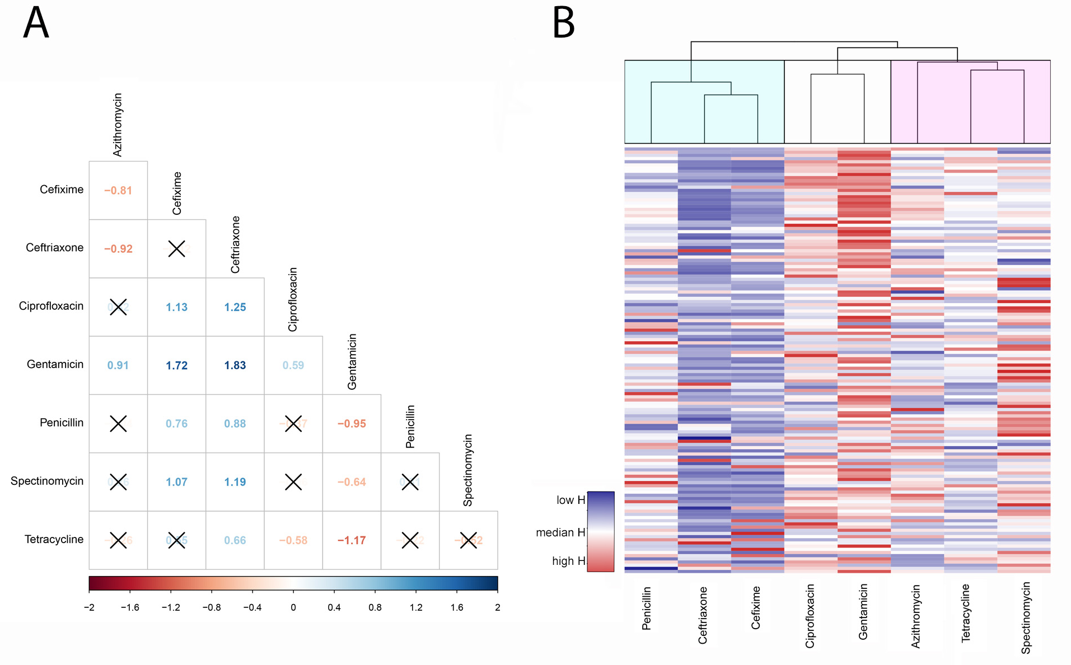

**Figure 1. Difference of Hill coefficients.** (A) The difference between the mean of 124 Hill coefficients (training and validation data) are shown for each antimicrobial combination. High values are shown in and increasing blue colour gradient and low values in red. A pairwise t-test was made and non-significant differences (p value < 0.05) marked with a black cross. (B) Hierarchical clustering of hill coefficients. Rows represent Hill coefficients for different strains (N=124) and columns antimicrobials. Antimicrobials could be grouped in three similarity clusters. The distance dendrogram for the cluster was highlighted in green, yellow and red (p-value of chi square test 0.018). The distance dendrogram for the rows is not shown since none of the differences found was significant.

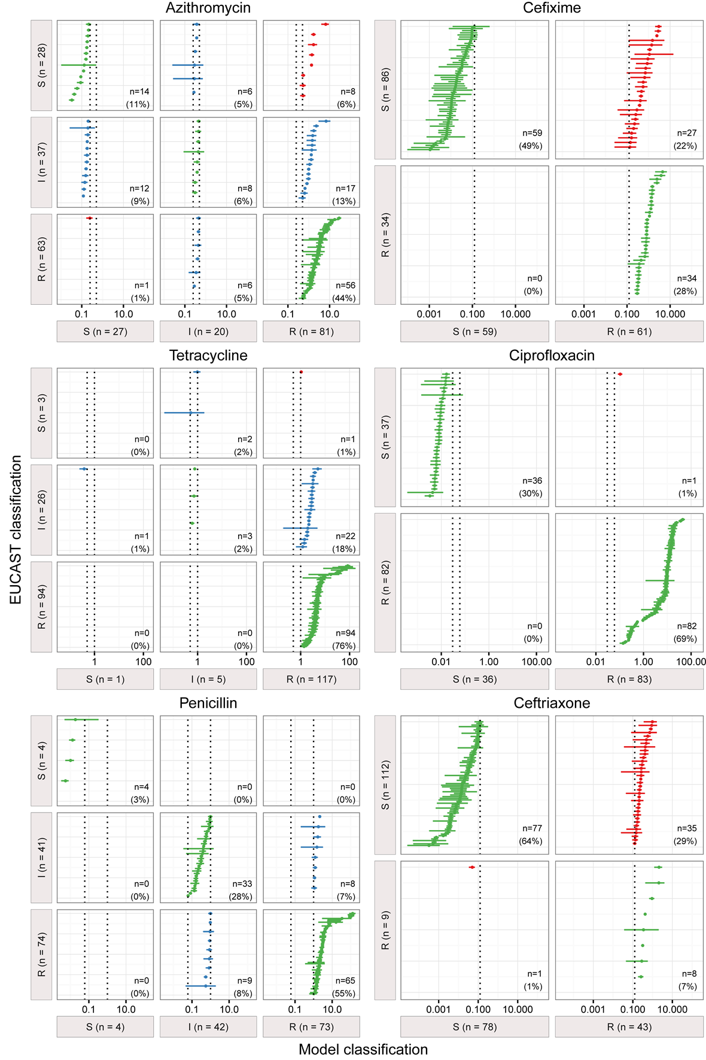

**Figure 2. Contingency table with categorical errors of model predicted MICs**. Etest data were classified according to the categories resistant (R), susceptible (S) and intermediary (I) when defined according to EUCAST 2016 criteria. The cutoff values (mg/L) are shown as dashed black lines. Predicted MIC values are shown as point estimate with 95% confidence interval. Correctly classified strains are depicted as green. Major errors (S to R) and very major errors (R to S) are shown in red. Minor errors resulting from misclassifications of intermediary strains are drawn in blue. Data below or above limit of detection were not included. Gentamicin and Spectinomycin were excluded from this analysis.